**University of Michigan – Dearborn**

**Department of Computer and Information Science**

**CIS 150L – Fall 2014**

Lab 2

Srinivas Simhan

09/22/14

**Table of Contents**

1. Question 1 3
   1. Screenshot 3
   2. Source Code 4
2. Question 2 5
   1. Screenshot 5
   2. Source Code 6
3. **Question 1**
   1. **Screenshot**

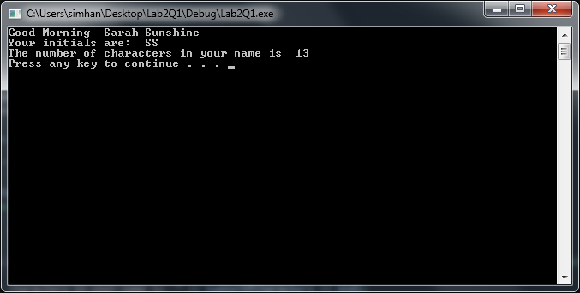

* 1. **Source Code**

//display initials and number of characters in a name

//Author: Srinivas Simhan

//Creation Date: 9/22/2014

#include <string>

#include <iostream>

using namespace std;

int main()

{

string first_name = "Sarah";

string last_name = "Sunshine";

string name;

int numberOfCharacters;

name = first_name + " " + last_name;

numberOfCharacters = first_name.length() + last_name.length(); // use length to compute the number

// of characters in the name

cout << "Good Morning " << name << endl;

cout << "Your initials are: " << first_name.at(0) << last_name.at(0) << endl; //you need to display the first character of the first name and the first character of the last name

cout << "The number of characters in your name is " << numberOfCharacters << endl;

system("pause");

return 0;

}

1. **Question 2**
   1. **Screenshot**

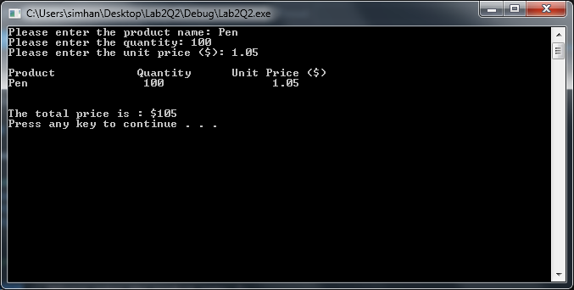

* 1. **Source Code**

1. #include <iostream>
2. #include <string> // library needed for strings
3. #include <iomanip>; // library needed for setw()
4. using namespace std;
5. int main()
6. {
7. string product;
8. int quantity;
9. float unitPrice;
10. float totalPrice;
12. /* To be filled in for data input from keyboard */
13. cout << "Please enter the product name: ";
14. cin >> product;
15. cout << "Please enter the quantity: ";
16. cin >> quantity;
17. cout << "Please enter the unit price ($): ";
18. cin >> unitPrice;
19. cout << endl;
20. // setw() is used to format display: to be explained in the lab
21. cout << "Product" << setw(20) << "Quantity" << setw(20) << "Unit Price ($)" << endl;
22. cout << product << setw(20) << quantity << setw(20) << unitPrice << endl << endl;
23. // to be filled: formula to compute the total price
24. totalPrice = quantity * unitPrice;
26. cout << endl;
27. cout << "The total price is : $" << totalPrice << endl;
28. system("pause");
29. return 0;
30. }